# About Licenses

License type compliances are grouped under License.

1. On the main menu, click My Workspace and then click License. The License screen appears as shown in the figure:

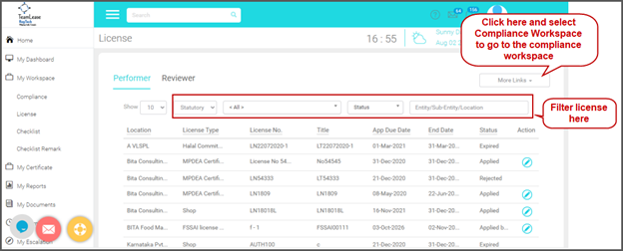

1. You can see list of licenses on various status appears. You may see two tabs if your user id is mapped with the Reviewer role:
   * Performer tab: Licenses to be performed /processed appears here
   * Reviewer tab: Licenses to be reviewed appears here
2. Use the filter options to filter licenses
   * Type: Select Statutory / Internal to filter statutory or internal licenses.
   * License Type: Select a type to find licenses based on the selected type. For example, if you want to filter licenses related to boiler, select boiler from the list. These types are defined in the back end.
   * Status: Select status to find licenses on selected status: Active / Expired / Expiring / Applied / Pending for Renewal / Rejected.
   * Location: Select Location / Branch to fetch licenses applicable to the location.

## Performing Expired Licenses

To perform an expired license, follow these steps:

1. On the main menu, click My Workspace and then click License. The License screen appears as shown in the figure:

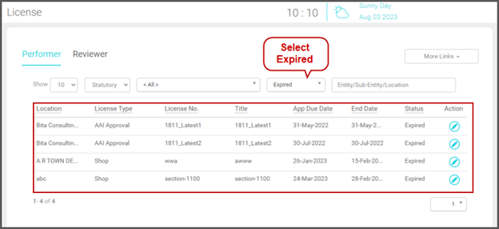

1. In the Status field, select Expired. Licenses with status Expired appears as shown in the above figure.
2. In the Action column, clickcontents/assets/images/image361.png to open the license. The License Details(s) screen appears as shown in the figure:

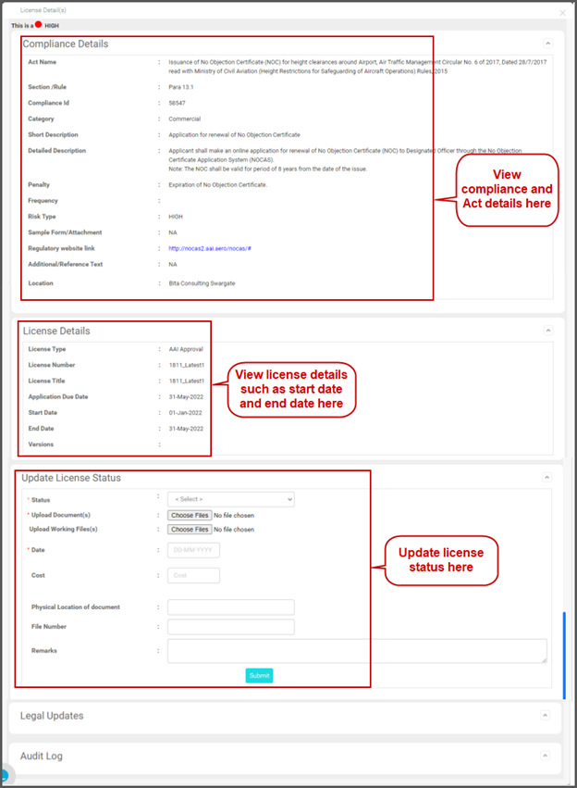

1. You can see the following sections:
   * Compliance Details: This section displays the Act details the compliance belongs. Details such as Act name and Section / Rule. This section also displays the compliance details such as Compliance Id, Short Description and Detailed Description and Frequency of the compliance etc.
   * License Details: In this section, you can see the license details such as License Type, License Number, License Title, Application Due Date, Start Date and End Date of the license.
   * Update Compliance Status: You will update this section while performing the license.
   * Legal Updates: This section enables you to view legal updates related to the compliances.
   * Audit Log: This section displays audit log of the compliance/license.
2. Under Update License Status, update the status of the license as shown in the figure:

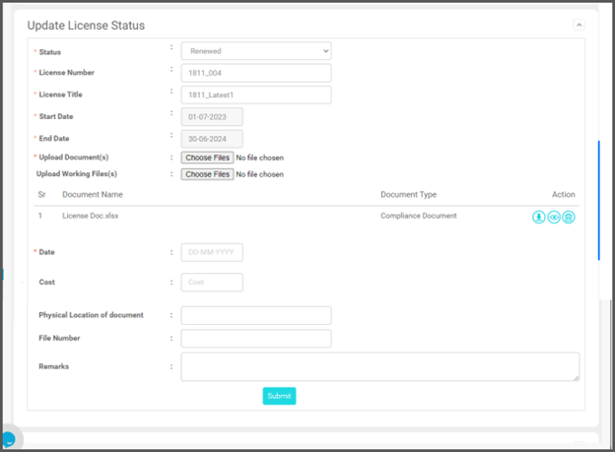

1. In the Status field, you can select any one of the following:
   * Applied but Pending for Renewal: Select this status if applied for renewal but renewal pending. When you select this status, the Upload Document(s) and Date fields becomes mandatory.
   * Renewed: Select this status, if the license is renewed. When you select this status, the License Number, License Title, license Start Date, End Date Upload Document(s) and Date fields becomes mandatory.
   * Terminate: Select this status to terminate the license. The Date field is filled with the current date automatically. If required you can change the date.
2. To renew the license, follow these steps:
3. In the Status field, select Renewed. The License Number, License Title, license Start Date and End Date fields appears.
4. In the License Number field, type the renewed license number.
5. In the License Title field, the title appears. If required, update the renewed license title.
6. In the Start Date, select the start date of the renewed license.
7. In the End Date field, select the end date/expiry date of the renewed license.
8. In the Upload Compliance Document(s) field, click Choose File and upload the documents. Once uploaded, you can do the following:
   * Clickcontents/assets/images/image365.png to download the document.
   * Clickcontents/assets/images/image364.png to view the document.
   * Clickcontents/assets/images/image366.png to delete the attached document
9. In the Upload Working File field, click Choose File and upload the documents if any. This is an optional field.
10. In the Date field, select the date of updating the license.
11. In the Physical Location of the Document field, type the physical location of the license document.
12. In the File No field, type the file number the document is stored
13. In the Remarks field, type your remarks if any.

Click Submit.